Karthik Pradeep Hegadi­­­­

**2KE20CS032­­­**

**Assignment 10**

*Understood. To follow the provided instructions and create the files/directory using the same name and case as provided in the task steps, please provide me with the specific names and case instructions for the files/directory you want to create.*

**PROCESS MANAGEMENT**

**Assignment 1**: Identify & Kill the process running on port 8065. (Mattermost should be up and running in port 8065)

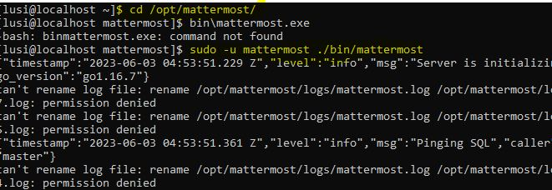

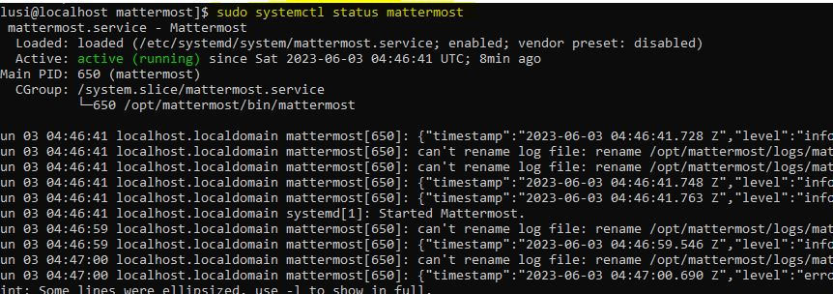



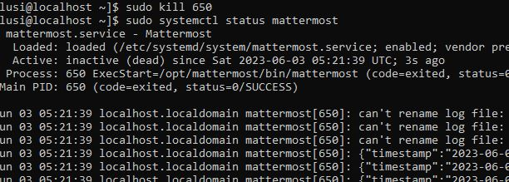

**Assignment 2:**

Identify & Kill the process running on port 80 (HTTP Apache server should be up and running in port 80)

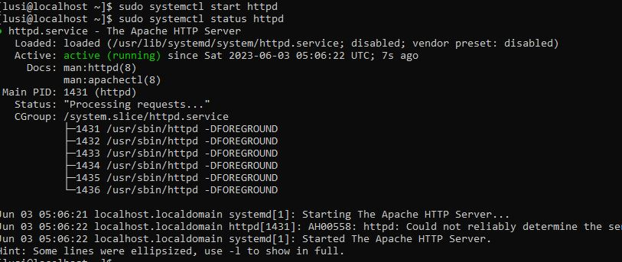



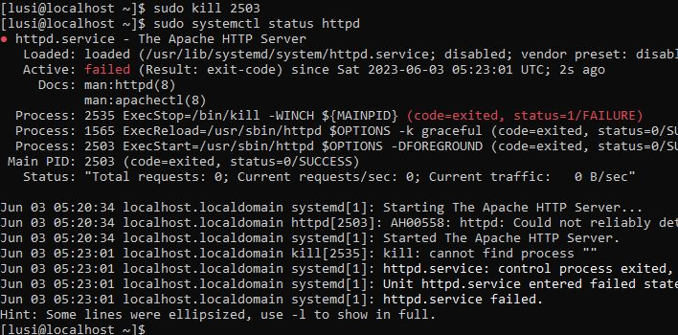

**Assignment 3:**

3.1: Run a job using the sleep command, for example: sleep 30 (It will make the shell sleep for 30 seconds).

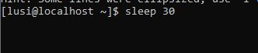

3.2: Now, send the running job to the background. It should continue executing in the background. To achieve this, you can use the following command:



3.3: To check if the job is running, you can use the jobs command:

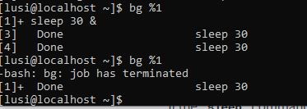

3.4: Close the terminal without killing the job. You can simply close the terminal window or use the exit command.

3.5: To check if the command is still running, you can use the ps command to list all processes:



Finally, the full task can be summarised as

